**DATABASE DESIGN**

1. User Sign-Up

|  |
| --- |
| Customer |
| Email id  Password  Name  Gender  Contact |

2. User Sign-In

|  |
| --- |
| User |
| Email id  Password |

3. Restaurants

|  |
| --- |
| Restaurants |
| ID  Name  Ratings  Location  Contact |

4. Cart items

|  |
| --- |
| Cart |
| Item  Quantity  Ratings  Price  Total price |

5. Extend items (pop-ups to add some more)

|  |
| --- |
| extend |
| Item  Quantity  Ratings  Price  Total price |

6. Offers

|  |
| --- |
| Cart |
| Item  Quantity  Ratings  Price  Total price |

7. Delivery boy

|  |
| --- |
| Delivery boy details |
| Name  ID  Password  Mobile Number  Location  Vehicle Number |

8. Job seeker

|  |
| --- |
| Job description |
| Job Id  Job title  Description |

10. Admin

|  |
| --- |
| Admin sign in |
| Id  Password |

**Architecture Diagram:**

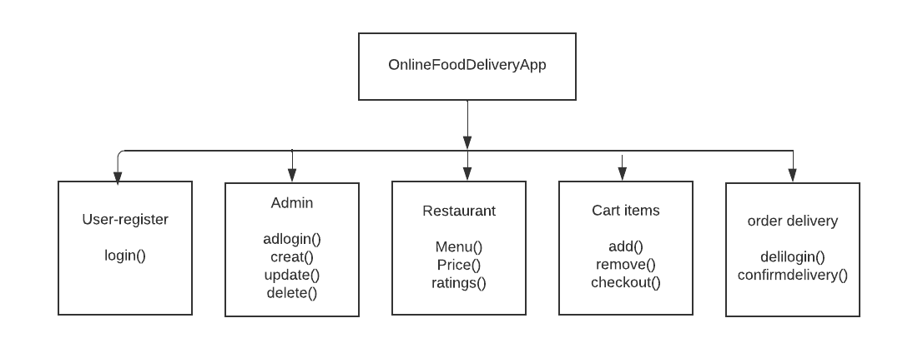

**UML Diagram**

1. Order Portal

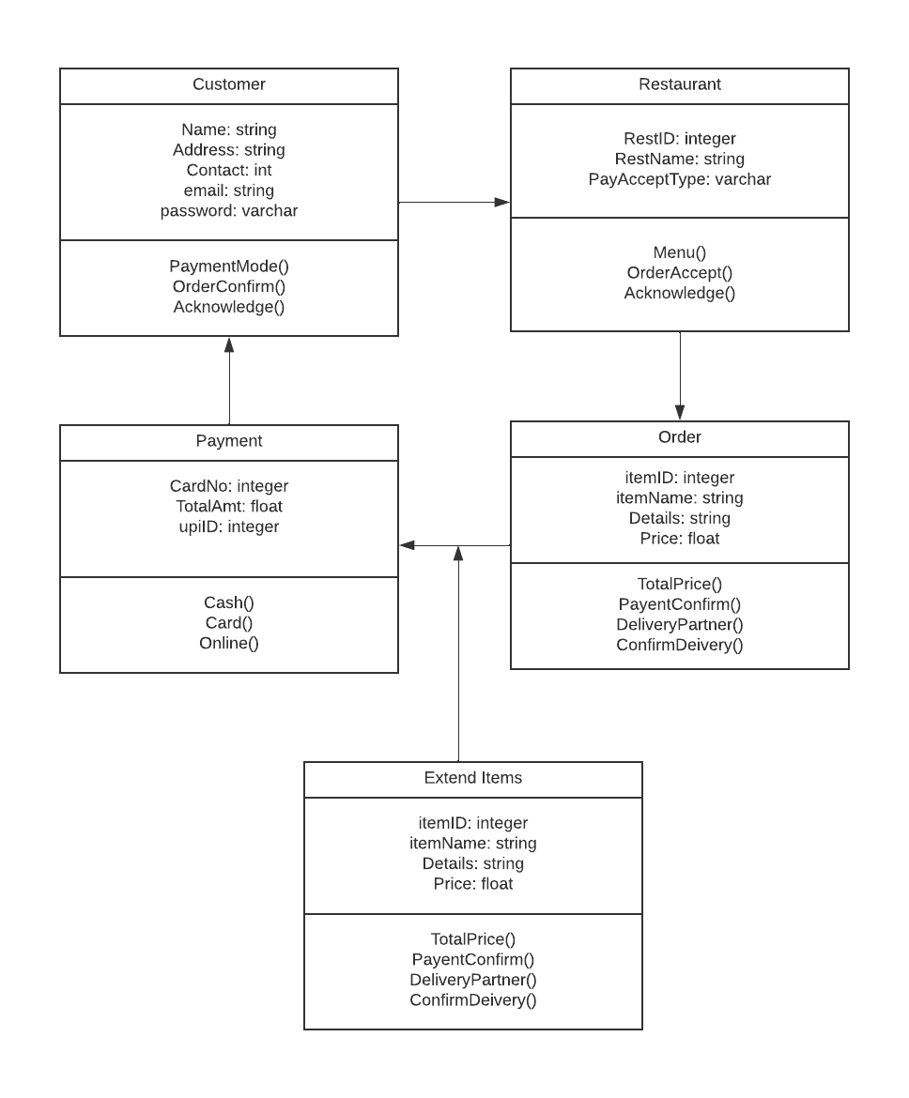

2. Delivery Portal

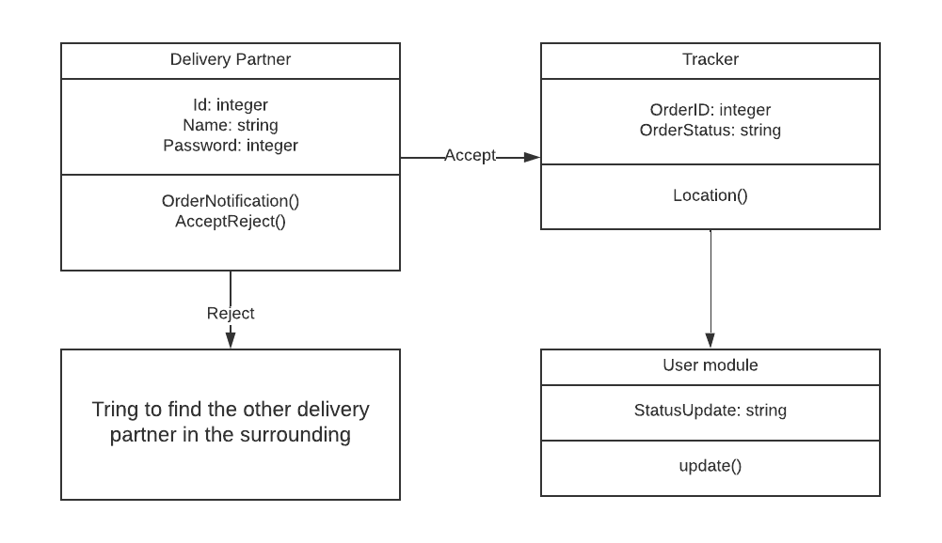

**Use-case Diagram**

